**Assignment No. 6**

**Problem Definition:**

You have a business with several offices; you want to lease phone lines to connect them up with each other; and the phone company charges different amounts of money to connect different pairs of cities. You want a set of lines that connects all your offices with a minimum total cost. Solve the problem by suggesting appropriate data structures

**Theory:**

Prim's algorithm to find minimum cost spanning tree (as Kruskal's algorithm) uses the greedy approach. Prim's algorithm shares a similarity with the **shortest path first** algorithms.

Prim's algorithm, in contrast with Kruskal's algorithm, treats the nodes as a single tree and keeps on adding new nodes to the spanning tree from the given graph.

To contrast with Kruskal's algorithm and to understand Prim's algorithm better, we shall use the same example −

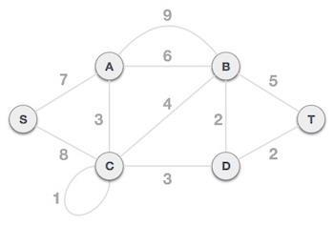

**Step 1 - Remove all loops and parallel edges**

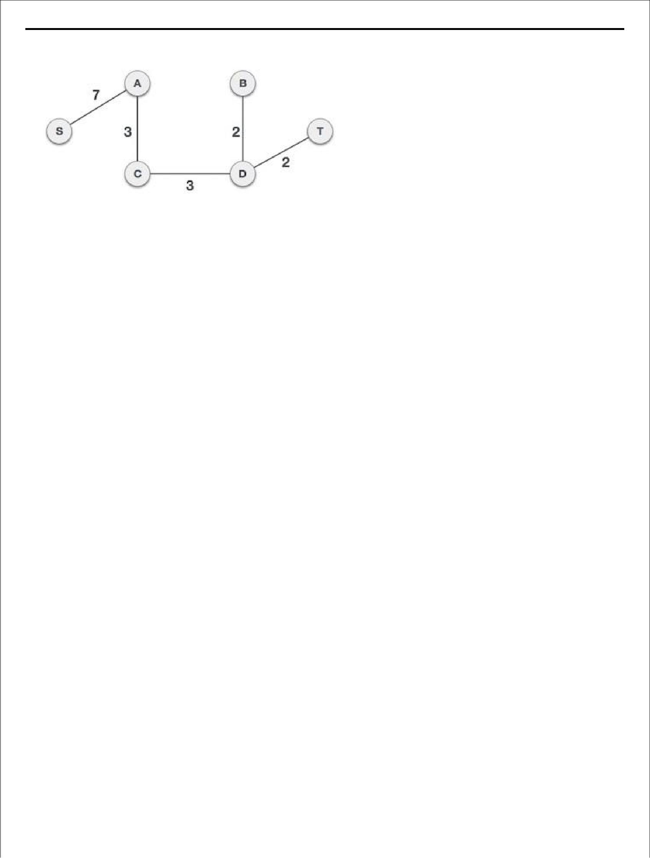

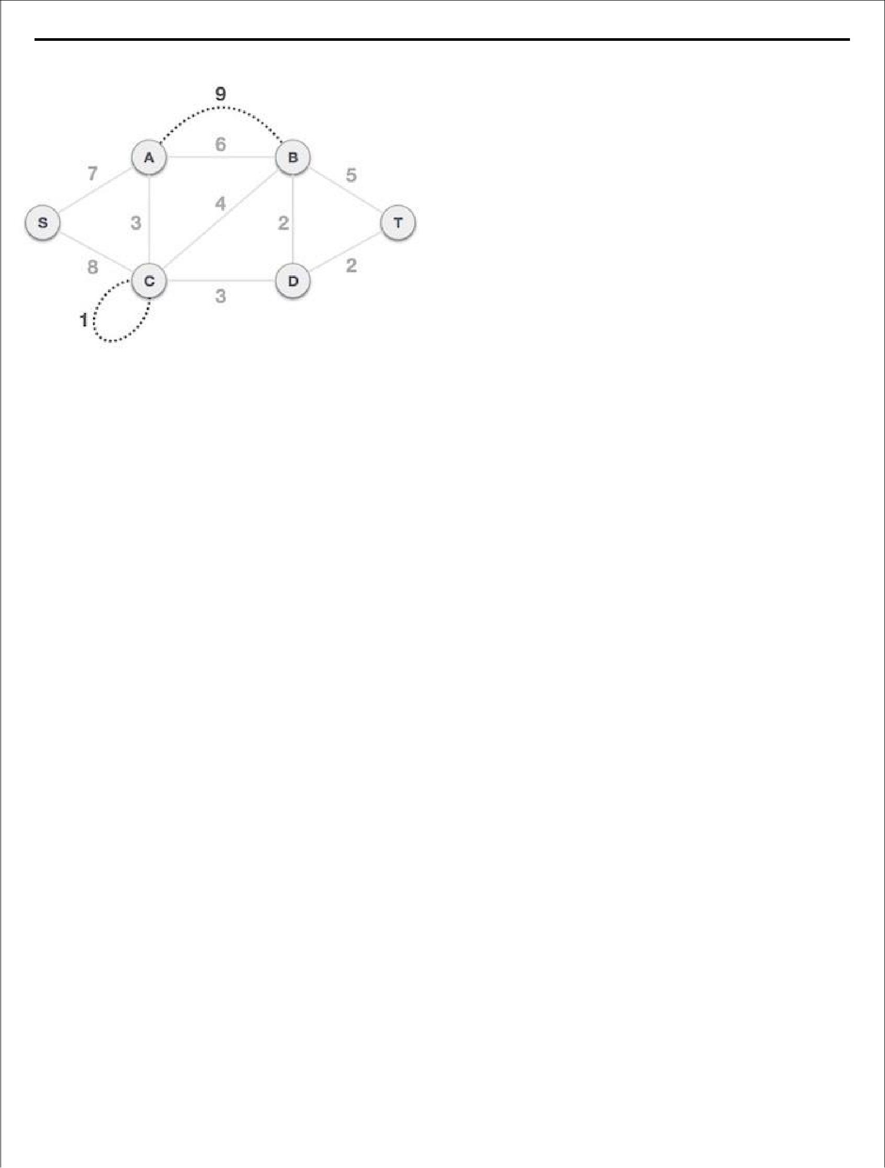

Remove all loops and parallel edges from the given graph. In case of parallel edges, keep the one which has the least cost associated and remove all others.

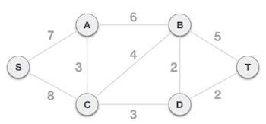

**Step 2 - Choose any arbitrary node as root node**

In this case, we choose **S** node as the root node of Prim's spanning tree. This node is arbitrarily chosen, so any node can be the root node. One may wonder why any video can be a root node. So the answer is, in the spanning tree all the nodes of a graph are included and because it is connected then there must be at least one edge, which will join it to the rest of the tree.

**Step 3 - Check outgoing edges and select the one with less cost**

After choosing the root node **S**, we see that S,A and S,C are two edges with weight 7 and 8, respectively. We choose the edge S,A as it is lesser than the other.

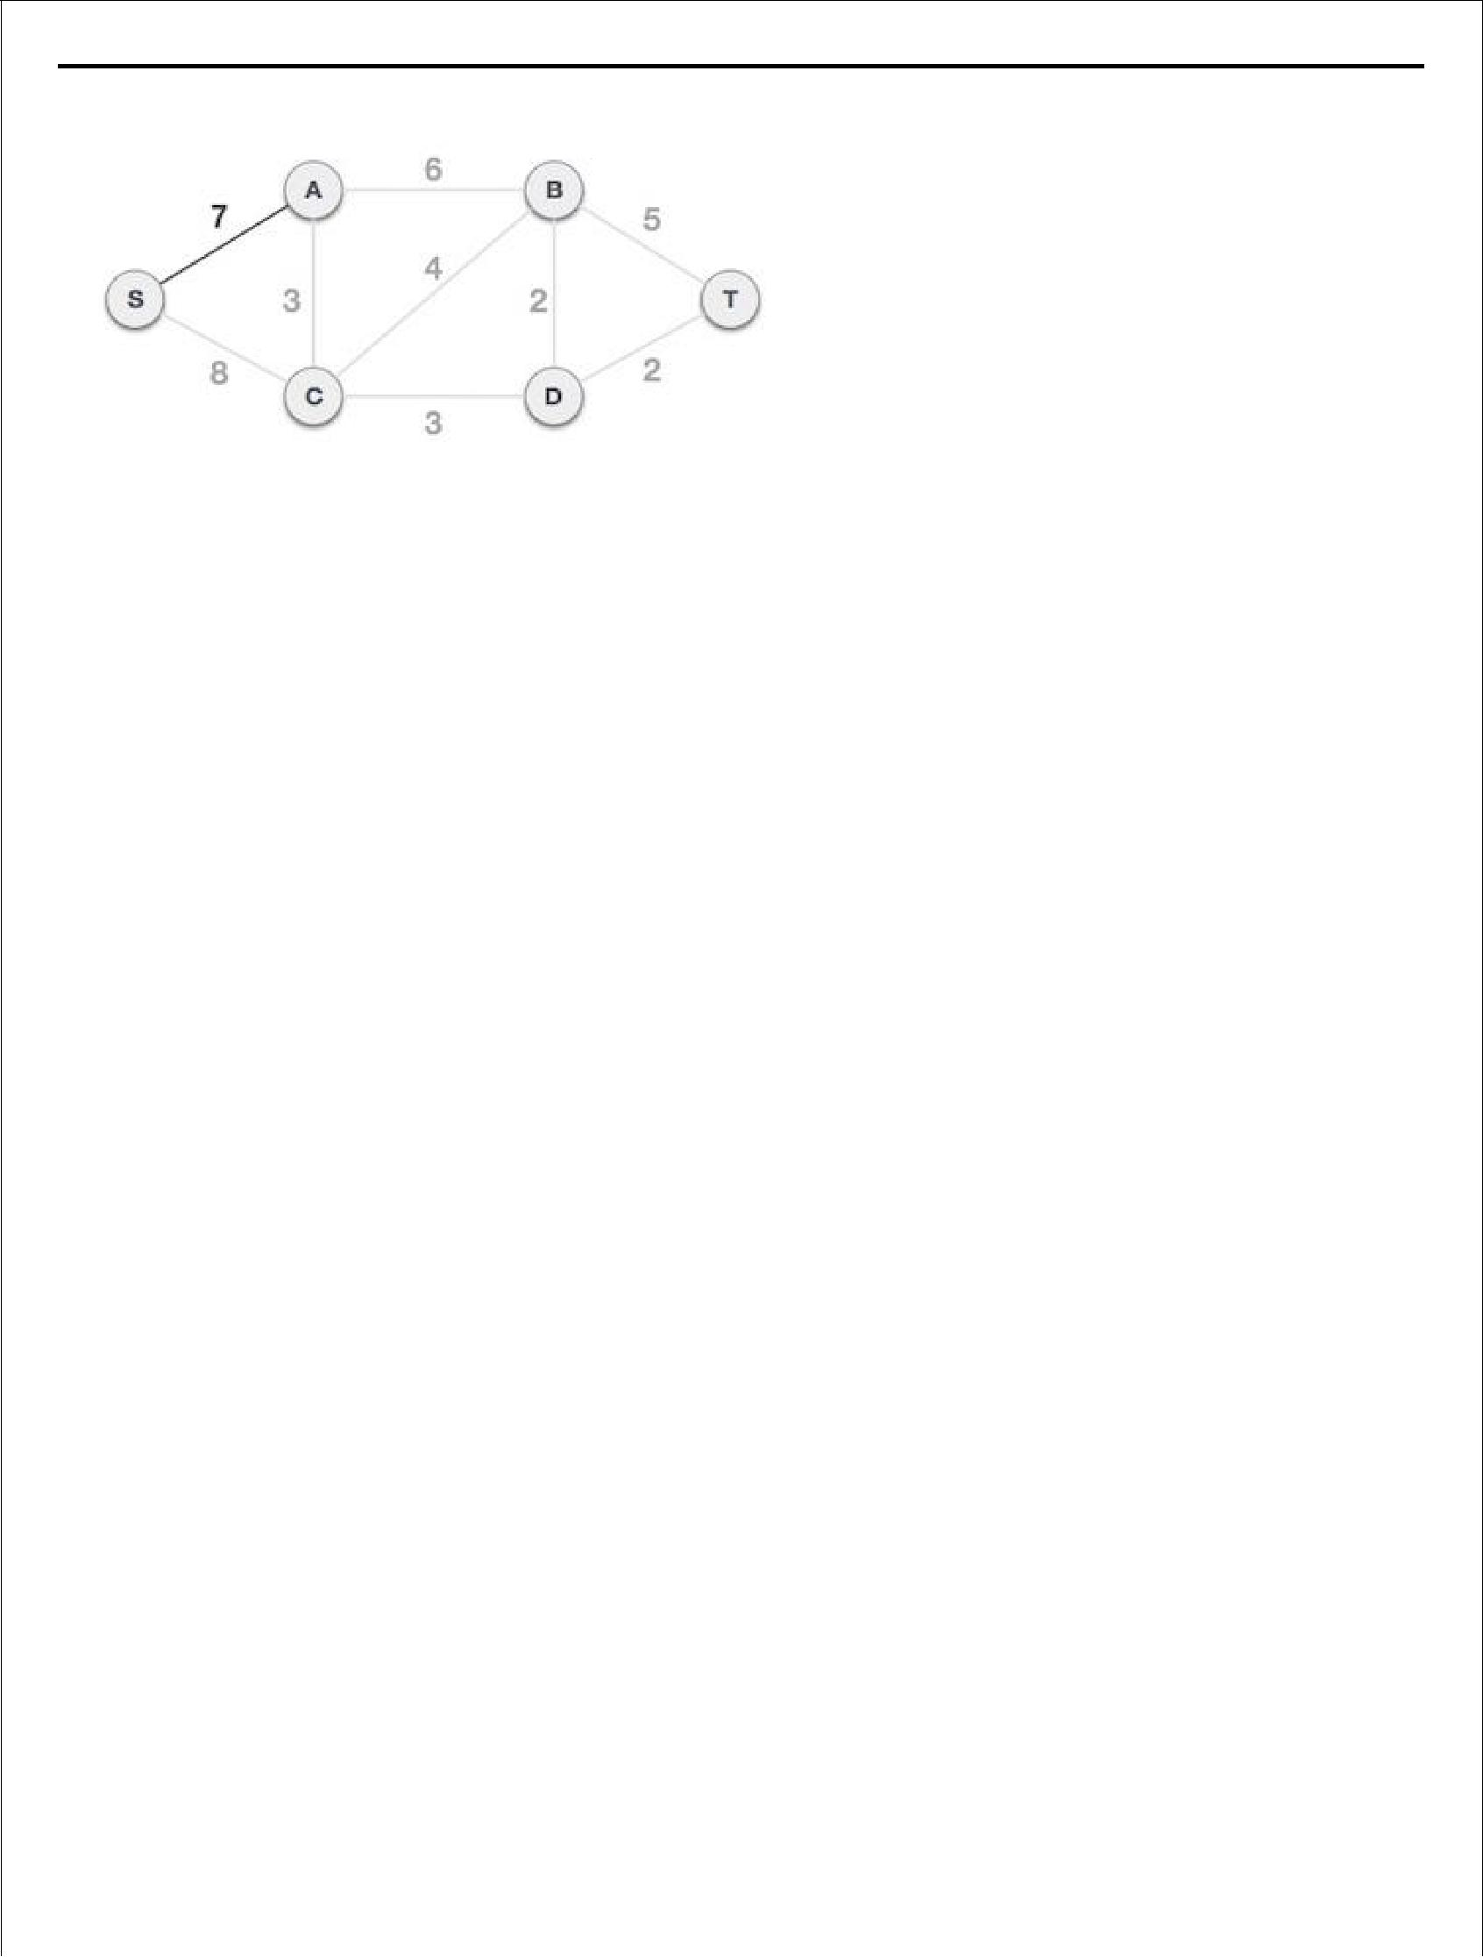

Now, the tree S-7-A is treated as one node and we check for all edges going out from it. We select the one which has the lowest cost and include it in the tree.

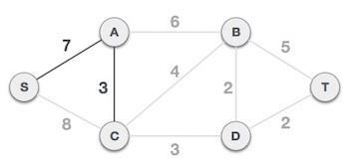

After this step, S-7-A-3-C tree is formed. Now we'll again treat it as a node and will check all the edges again. However, we will choose only the least cost edge. In this case, C-3-D is the new edge, which is less than other edges' cost 8, 6, 4, etc.

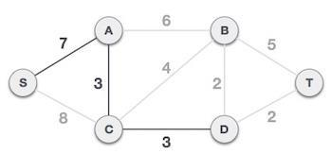

After adding node **D** to the spanning tree, we now have two edges going out of it having the same cost, i.e. D-2-T and D-2-B. Thus, we can add either one. But the next step will again yield edge 2 as the least cost. Hence, we are showing a spanning tree with both edges included.

1. Create a tree containing a single vertex, chosen arbitrarily from the graph
2. Create a set containing all the edges in the graph
3. Loop until every edge in the set connects two vertices in the tree
4. Remove from the set an edge with minimum weight that connects a vertex in the tree with a vertex not in the tree
5. Add that edge to the tree

**ALGORITHM:**

**Create Function:**

Step 1: Start.

Step 2: Create char, integer variable.

Step 3: Take how many vertices of graph and then take vertices ofedges and cost of edges. Step 4: Store zero in visited array and matrix array for graph.

Step 5: Vertex is -99 then break loop, otherwise stored arrayg[v1][v2]=cost. If cost is stored then also g[v2][v1] alsostore same cost.

Step 6: Ask user whether he wants to enter more edges if ‘Yes’ thengoto Step 7.

Step 7: Stop.

**Display Function:**

Step 1: Start.

Step 2: Using two for loop print cost of edges of matrix array onscreen.

Step 3: Stop

**Prims Function:**

Step 1: Start.

Step 2: Initially declare cost, matrix, visited from distance array.

Step 3: Using two for loop check if edge is present or not. If notthen stored infinity value else stored cost of G matrix incost matrix and then stored zero in st matrix.

Step 4: Take first vertex and using for take all distances in from thatvertex in distance array and put zero in

from and visited arrayat that vertex position.

Step 5: Initialize min cost =0 and no of edge=n-1.

Step 6: Using while loop take min distance infinity and again use forloop, check vertex is not visited and distance of that vertexis less min distance. If true then v = i and min distance=thatdistance.

Step 7: Stored that cost in st matrix for both vertices, edges anddecrease no of edge. Visited array is initialized = 1.

Step 8: Using for loop check vertex is not visited and distance isminimum. If true then stored that vertex in from array andCost of that edges in distance array.

Step 9: Add all min cost stored in min cost and return min cost. Stop 10: Stop.

**Main Function:**

Step 1: Start.

Step 2: Create object of graph and Integer and character variables.

Step 3: Print Menu like

1. Create.
2. Display.
3. Spanning Tree and find minimum cost. Step 4: Take choice from user.

Step 5: If choice is 1 then call Create Function. Step 6: If choice is 2 then call Display Function. Step 7: If choice is 3 then call prims Function.

Step 8: Ask user whether he wants to continue or not. Step 9: If yes then go to step 3.

Step 10: Stop.

**OUTPUT** :-

1 for create graph

2 for prims_mst

3 for exit

Enter Your Choice1

enter no. of offices 5

enter no. of lanes 8

enter lane in v1,v2 form 0 1

enter weight of Lane 3

enter lane in v1,v2 form 1 2

enter weight of Lane 3

enter lane in v1,v2 form 2 3

enter weight of Lane 4

enter lane in v1,v2 form 3 0

enter weight of Lane 3

enter lane in v1,v2 form 3 4

enter weight of Lane 1

enter lane in v1,v2 form 4 1

enter weight of Lane 2

enter lane in v1,v2 form 0 4

enter weight of Lane 2

enter lane in v1,v2 form

4 2

enter weight of Lane 1

1 for create graph

2 for prims_mst

3 for exit

Enter Your Choice2 1

The o/p is : H 0-->H 4 H 4-->H 2 H 2-->H 3

The Cost Of MST Is :7 1 for create graph

2 for prims_mst

3 for exit

Enter Your Choice3

**Assignment Questions**:

1. What is Spanning Tree?
2. What is Minimum Spanning Tree?
3. What is Prim‟s Algorithm?
4. What is Kruskal‟s Algorithm?
5. What are Applications of Minimum Spanning Tree?
6. How to decide whether to select Kruskal‟s algorithm or Prim‟s algorithm
7. What is shortest path algorithm?
8. What is minimum spanning tree of a graph?
9. How to calculate shortest path of graph?